# Lab: Unit Testing and Error Handling

Problems for exercises and homework for the ["JavaScript Advanced" course @ SoftUni](https://softuni.bg/trainings/3588/js-advanced-january-2022).

Submit your solutions in the SoftUni judge system at https://judge.softuni.bg/Contests/2766/Unit-Testing-Lab.

# Error Handling

## Sub Sum

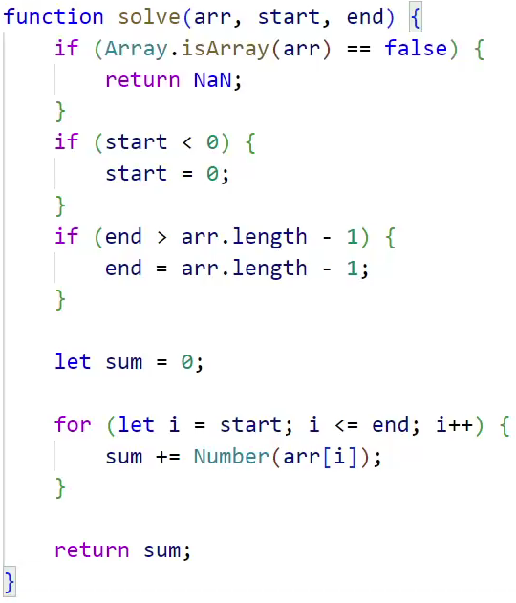

Write a function to sum a **range** of **numeric elements** from an array.

The function takes **three parameters** - the first is an array, the second is the start index and the third is the end index. Both indexes are **inclusive**. Have in mind that the array elements **may not be** of type Number and **cast everything**. Implement the following error handling:

* If the **first element** is not an array, return NaN
* If the **start index** is less than zero, consider its value to be a **zero**
* If the **end index** is outside the bounds of the array, assume it points to the **last index of the array**

### Input / Output

Your function must take **three** **parameters**. As output, return the sum.

### Examples

|  |  |
| --- | --- |
| Input | Output |
| [10, 20, 30, 40, 50, 60], 3, 300 | 150 |
| [1.1, 2.2, 3.3, 4.4, 5.5], -3, 1 | 3.3 |
| [10, 'twenty', 30, 40], 0, 2 | NaN |
| [], 1, 2 | 0 |
| 'text', 0, 2 | NaN |

## Playing Cards

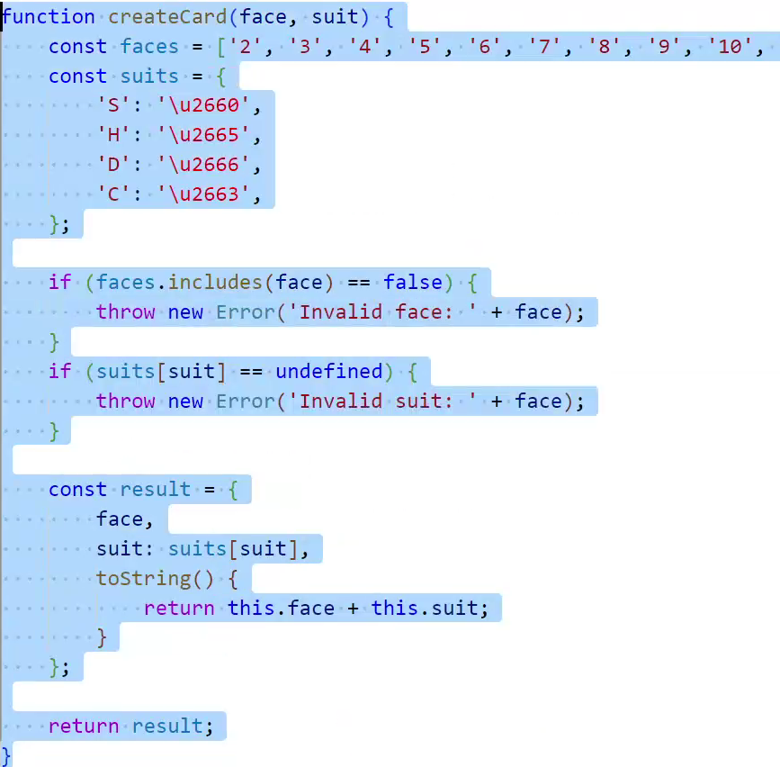

Create a JS **factory function** that returns a Card object holding the card’s face and suit. Throw an error if the card is initialized with an **invalid** **face**.

* Valid card faces are: 2, 3, 4, 5, 6, 7, 8, 9, 10, J, Q, K, A
* Valid card suits are: S (♠), H (♥), D (♦), C (♣)

Both face and suit are expected as an uppercase string. The object also needs to have a toString() method that **prints** the card’s face and suit **as a** string. Use the following UTF code literals to represent the suits:

* \u2660 – Spades (♠)
* \u2665 – Hearts (♥)
* \u2666 – Diamonds (♦)
* \u2663 – Clubs (♣)

### Input / Output

The factory function takes **two string parameters**. The toString() method of the returned object must return a string.

### Examples

|  |  |
| --- | --- |
| Input | Output |
| 'A', 'S' | A♠ |
| '10', 'H' | 10♥ |
| '1', 'C' | Error |

## Deck of Cards

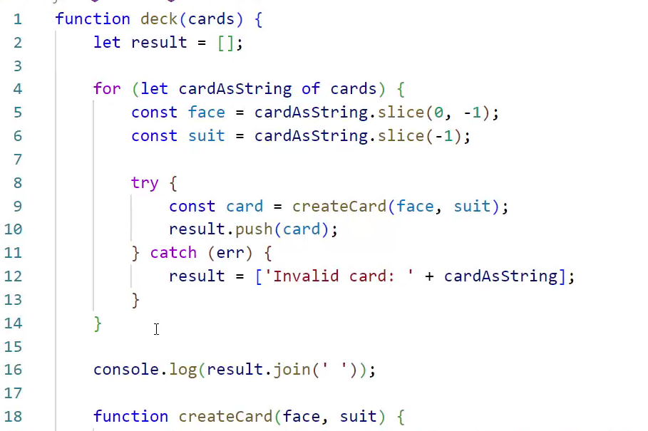

Write a function that takes **a deck of cards** as anarray of strings and **prints** them as a **sequence** of cards (**space separated**). Use the solution from the **previous task** to generate the cards.

Print **`**Invalid card: ${card}**`** when an **invalid card** definition is passed as input.

### Input / Output

The function takes anarray of strings as a parameter. **Print** the list of cards as string, **separated by space**.

|  |
| --- |
| deckOfCards.js |
| function printDeckOfCards(cards) {  function createCard (){  *// Use the solution from the previous task*  }  *// TODO*  } |

### Examples

|  |  |
| --- | --- |
| Sample Input | Sample Output |
| ['AS', '10D', 'KH', '2C'] | A♠ 10♦ K♥ 2♣ |
| ['5S', '3D', 'QD', '1C'] | Invalid card: 1C |

# Unit Testing

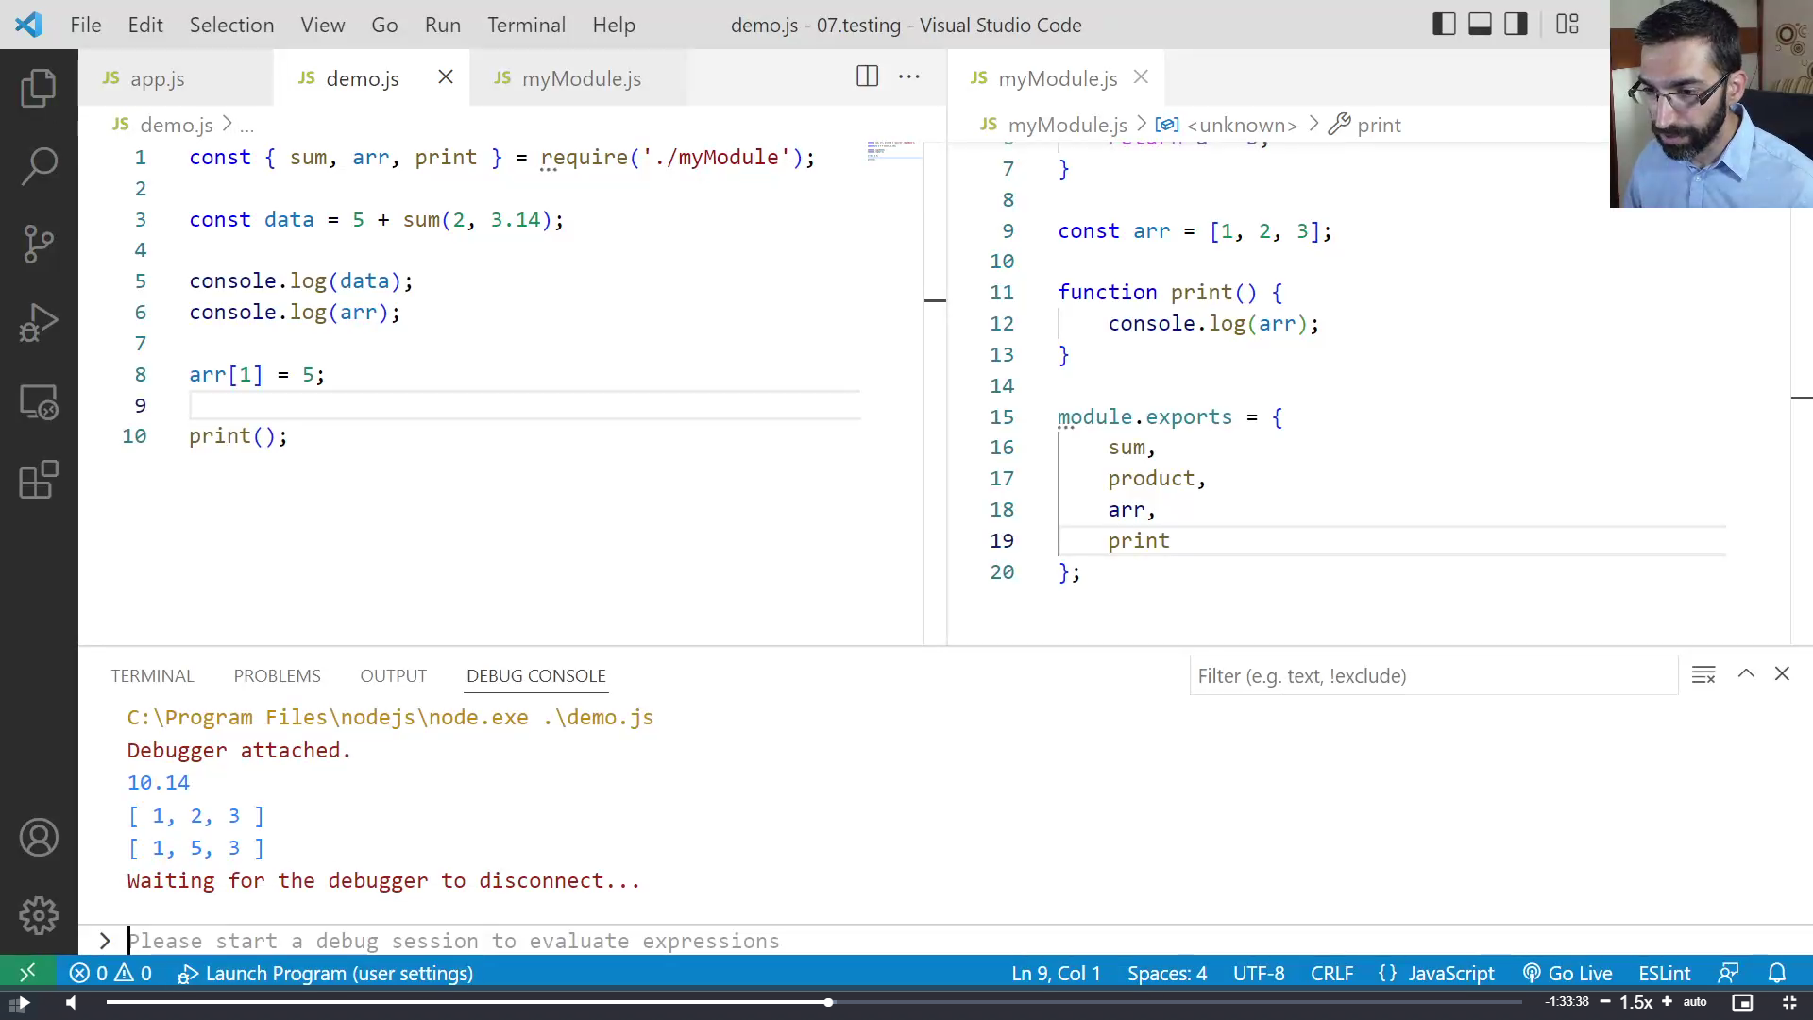

You are required to **submit only the** unit tests for the object**/**function you are testing.

## Sum of Numbers

Write tests to check the functionality of the following code:

|  |
| --- |
| sumNumbers.js |
| **function** *sum*(arr) {  **let** sum = 0;  **for** (let num **of** arr){  sum += Number(num);  }  **return** sum; } |

Your tests will be supplied with a function named 'sum()'. It should meet the following requirements:

* Take an array of numbers as an argument
* Return the **sum** of the values of **all elements** inside the array

## Check for Symmetry

Write tests to check the functionality of the following code:

|  |
| --- |
| checkForSymmetry.js |
| **function** *isSymmetric*(arr) {  **if** (!Array.isArray(arr)){  **return false**; ***// Non-arrays are non-symmetric***  }**let** reversed = arr.slice(0).reverse(); ***// Clone and reverse*****let** equal = (JSON.stringify(arr) == JSON.stringify(reversed));  **return** equal;  } |
|  |

Your tests will be supplied with a function named 'isSymmetric()'. It should meet the following requirements:

* Take an array as an argument
* Return false for any input that isn’t of the correct type
* Return true if the input array is **symmetric**
* Otherwise, return false

## RGB to Hex

Write tests to check the functionality of the following code:

|  |
| --- |
| rgb-to-hex.js |
| **function** *rgbToHexColor*(red, green, blue) {  **if** (!Number.isInteger(red) || (red < 0) || (red > 255)){  **return** undefined; ***// Red value is invalid***  }**if** (!Number.isInteger(green) || (green < 0) || (green > 255)){  **return** undefined; ***// Green value is invalid***  }**if** (!Number.isInteger(blue) || (blue < 0) || (blue > 255)){  **return** undefined; ***// Blue value is invalid***  }**return "#"** +  (**"0"** + red.toString(16).toUpperCase()).slice(-2) +  (**"0"** + green.toString(16).toUpperCase()).slice(-2) +  (**"0"** + blue.toString(16).toUpperCase()).slice(-2); } |

Your tests will be supplied with a function named 'rgbToHexColor()', which takes **three arguments**. It should meet the following requirements:

* Take three integer numbers, representing the red, green, and blue values of RGB color, each within the range [0…255]
* Return the same color in hexadecimal format as a string (e.g. **'#FF9EAA'**)
* Return undefined if **any** of the input parameters are of an invalid type or **not** in the **expected range**

## Add / Subtract

Write tests to check the functionality of the following code:

|  |
| --- |
| addSubtract.js |
| **function** *createCalculator*() {  **let** value = 0;  **return** {  add: **function**(num) { value += Number(num); },  subtract: **function**(num) { value -= Number(num); },  get: **function**() { **return** value; }  } } |
|  |

Your tests will be supplied with a function named 'createCalculator()'. It should meet the following requirements:

* Return a module (object), containing the functions add(), subtract() and get() as properties
* Keep an **internal sum** that **can’t be modified** from the outside
* The functions add() and subtract() take a parameter that can be **parsed as a number** (either a number or a string containing a number) that is added or subtracted from the **internal sum**
* The function get() returns the value of the **internal sum**